PROJECT DOCUMENTATION
AI Weather Wise
TEAM ID:SWTID-2026-7596
Student / Team Introduction
Role | Name | Register No. | Email
Team Leader | Harini A | 212404221 | harinivasanthi07@gmail.com
Team Member | Srisankari KS | 212404247 | srisankarikarthi@gmail.com
Team Member | S Shabana Yasmin | 212404242 | shabanayasmin131@gmail.com
Team Member | Vijiyalakshmi B | 212404251 | vijayalakshmi1462007@gmail.com
Project Introduction
Artificial Intelligence (AI) in Weather Forecasting is a technology-based approach that uses weather data
and intelligent algorithms to identify patterns and predict future weather conditions. It can work with
information such as temperature, humidity, rainfall, wind speed and atmospheric pressure.
The project explains how AI can support weather prediction, weather-data analysis and timely decision
making.

1. Project Overview
Weather forecasting involves collecting atmospheric information and using it to estimate future weather
conditions. Traditional forecasting methods depend on scientific models, observations and historical
records. AI adds data-driven techniques that can learn patterns from large datasets.
An AI-based weather forecasting system can process historical and current weather information and
produce predictions such as temperature, rainfall, wind conditions and other weather-related parameters.
The main idea of this project is to demonstrate the role of Artificial Intelligence in analyzing weather
information and supporting forecasting.
2. Objectives
• To understand the role of AI in weather forecasting.
• To analyze historical and current weather data.
• To identify patterns in weather conditions.
• To support prediction of temperature, rainfall and other weather parameters.
• To provide useful information for planning and decision making.

3. How AI Predicts Weather
AI weather forecasting generally follows a data-processing and prediction workflow. Weather data is first
collected from available sources. The data is then cleaned and prepared so that an AI model can learn
from it.
The prepared data is supplied to a machine learning model. The model learns relationships between
previous weather observations and future conditions. After training, the model can use new weather inputs
to generate predictions.
Basic Working Flow
Weather Data Collection | ↓
Data Cleaning & Preparation | ↓
AI / ML Model | ↓
Pattern Analysis & Prediction | ↓
Weather Forecast Output
The output can be presented through tables, charts, dashboards or a weather application interface.

4. Weather Data Used by AI
AI models require suitable weather data to learn patterns. Common variables used in weather forecasting
include:
• Temperature – indicates the level of heat or cold.
• Humidity – represents the amount of moisture in the air.
• Rainfall – provides information about precipitation.
• Wind Speed – indicates how fast air is moving.
• Wind Direction – shows the direction of air movement.
• Atmospheric Pressure – provides information about pressure conditions.
• Historical Weather Records – help the model learn previous patterns.
Data Preparation
Before training, weather data may need cleaning, removal of duplicate or incorrect records, handling of
missing values, and conversion into a suitable format. Good-quality data is important because the
prediction model depends on the information supplied to it.

5. AI Techniques in Weather Forecasting
Different machine learning and AI techniques can be used to analyze weather data. The choice of
technique depends on the type of data and the forecasting problem.
Technique | Purpose
Regression | Predicts numerical values such as temperature.
Classification | Groups weather conditions into categories.
Time-Series Analysis | Studies weather values over time.
Decision Trees | Uses data-based rules for prediction.
Neural Networks | Learns complex patterns from large datasets.
AI models can be trained using historical weather observations. Once trained, the model can receive new
observations and estimate future conditions.

6. System Architecture
The system architecture describes how weather information moves through the AI forecasting system.
Component | Description
Data Source | Provides historical and current weather information.
Data Processing | Cleans, prepares and organizes weather data.
AI Model | Learns patterns and relationships from the prepared data.
Prediction Engine | Uses the trained model to generate forecasts.
Output / Visualization | Displays predicted weather information to users.
System Architecture Flow
Weather Data →Data Processing →AI Model →Prediction →Visualization
This architecture provides a simple structure for building an AI-based weather forecasting application.
Backend Project Structure
The backend of the AI Weather Wise application is organised as a Node.js project. The main files and folders are shown below.
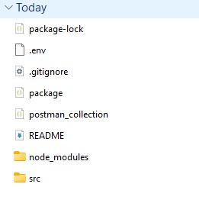
Figure 1: Backend Project Structure
src – contains the server and API source code (server.js).
package.json / package-lock.json – project details and installed dependencies.
.env – stores configuration values such as the database connection and port.
.gitignore – lists files that should not be uploaded to the repository.
postman_collection – saved API requests used for testing.
README – describes the project and how to run it.

7. Modules of the System
1. Data Collection Module
Collects weather observations required for analysis and prediction.
2. Data Cleaning Module
Handles missing, duplicate or unsuitable data and prepares the dataset.
3. Data Analysis Module
Examines weather variables and identifies useful patterns.
4. AI Model Module
Trains an AI or machine learning model using prepared weather data.
5. Prediction Module
Generates weather predictions from new input data.
6. Visualization Module
Displays weather information using tables, charts or dashboards.
8. Implementation & Output
The backend server was built with Node.js and Express and connected to a MongoDB database. It was started with npm run dev and runs on port 5001. The API was tested using the Thunder Client extension in VS Code.
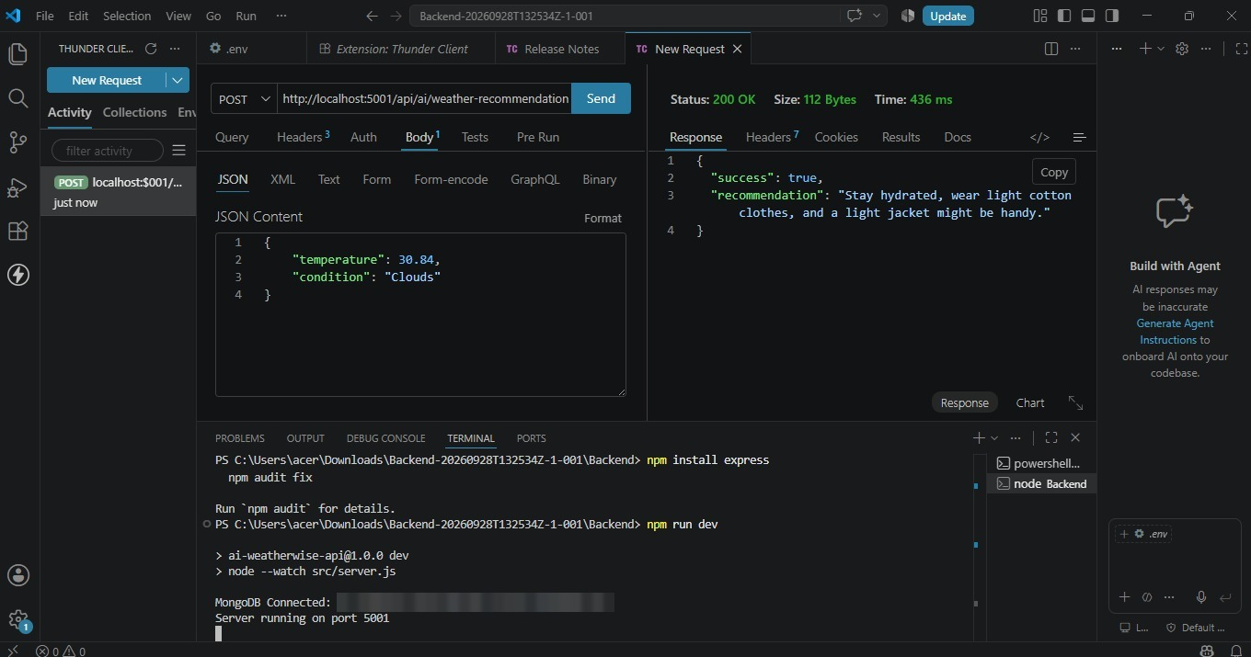
Figure 2: Weather Recommendation API – 200 OK
Request: POST /api/ai/weather-recommendation with temperature 30.84 and condition “Clouds”.
Response: success = true, with a recommendation to stay hydrated, wear light cotton clothes and carry a light jacket.
The terminal confirms that the database is connected and the server is running on port 5001. This output demonstrates the Prediction Module (recommendation generated from weather input) and the Visualization Module (result shown to the user).
Additional Screenshots
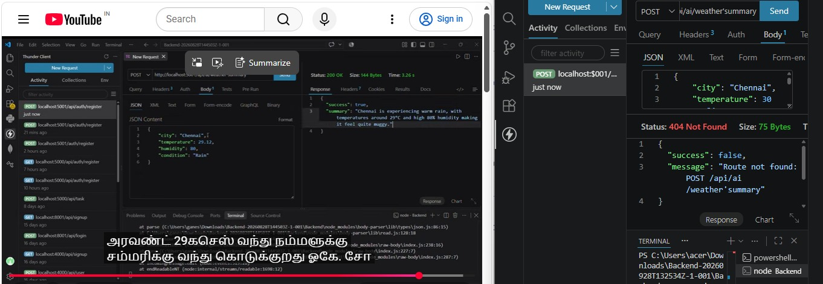
Figure 3: Weather Summary API testing – route not found (404)
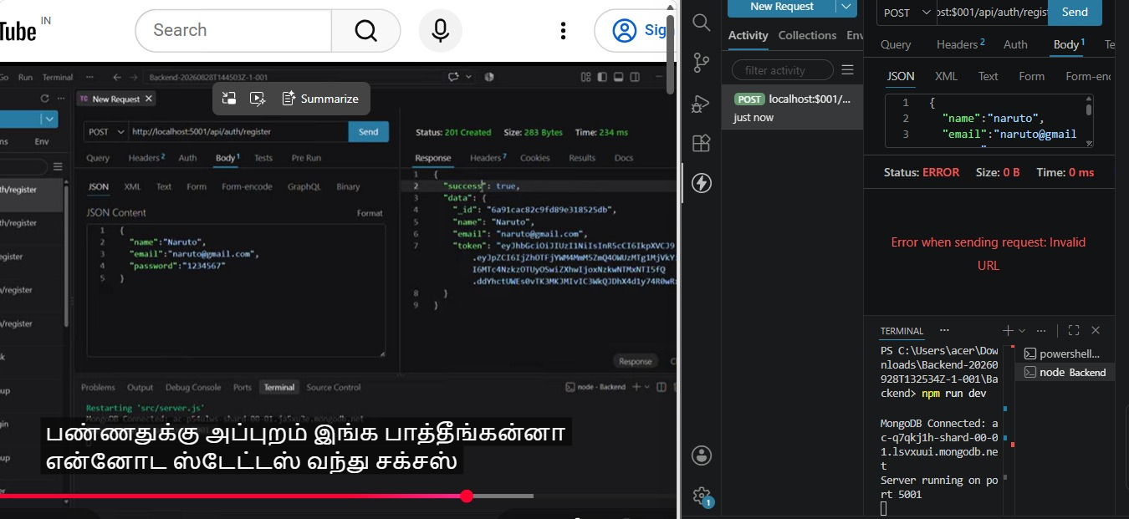
Figure 4: User Registration API testing
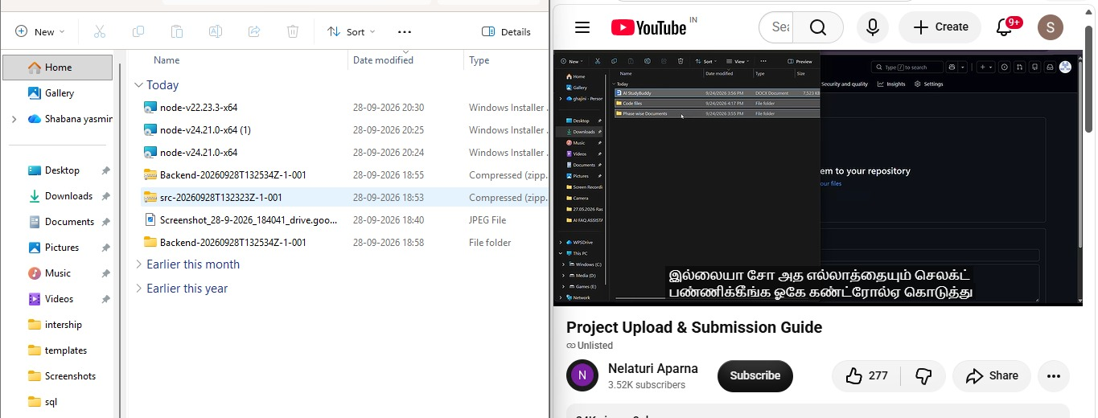
Figure 5: Project upload and submission steps
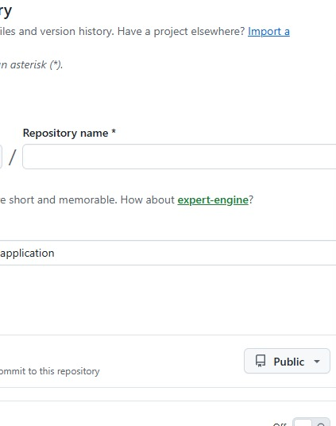
Figure 6: GitHub – Create a new repository
Repository link: (to be added)

9. Features and Applications
Features
• Analyzes large amounts of weather data.
• Identifies patterns in historical weather conditions.
• Supports automated prediction.
• Can present results through charts and dashboards.
• Can be extended to different weather parameters.
Applications
• Agriculture – supports planning based on expected weather conditions.
• Disaster Management – can support preparation for severe weather events.
• Transportation – weather information can assist travel planning.
• Aviation – weather predictions are important for flight planning and safety operations.
• Daily Planning – helps people understand expected weather conditions.

10. Advantages, Limitations and Future Scope
Advantages
• Can process large weather datasets efficiently.
• Can identify patterns that may be difficult to observe manually.
• Supports faster data-driven forecasting.
• Can automate repeated analysis tasks.
• Can provide useful visual reports.
Limitations
• Prediction quality depends on the quality and quantity of available data.
• Unexpected weather events can be difficult to predict accurately.
• AI models require suitable training and testing.
• Computational resources may be required for large datasets.
Future Scope
• Use larger and more diverse weather datasets.
• Improve prediction models using advanced AI techniques.
• Develop real-time weather forecasting applications.
• Integrate weather alerts and interactive dashboards.

11. Conclusion
AI in Weather Forecasting demonstrates how Artificial Intelligence can be used to analyze weather
information and support prediction. By learning from historical and current weather data, AI-based systems
can identify patterns and generate useful forecasts.
The project provides a simple understanding of the complete forecasting process, from data collection and
preparation to AI-based prediction and visualization. AI can therefore serve as an important tool for
modern weather-data analysis and forecasting applications.
Project Summary
Project Title: AI in Weather Forecasting
Team Leader: Harini A – 212404221
Team Members: Srisankari KS – 212404247; S Shabana Yasmin – 212404242; Vijiyalakshmi B –
212404251
THANK YOU

